Project Deliverable 3

WAR Game

By: Manraj Garg and Paul Tracz

Table of Contents

|  |  |
| --- | --- |
| UML Diagram | Page 2 |
| Use Case | Page 3 |

GitHub Repository

https://github.com/briansilvera/SYST-17796-Project

Final UML Diagram

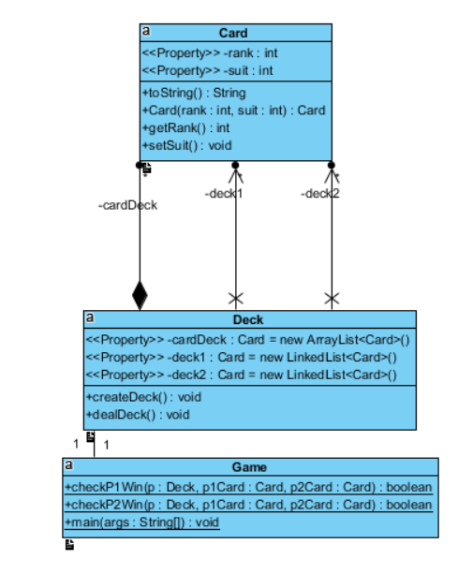

Figure 1.

Final Use Case Diagram

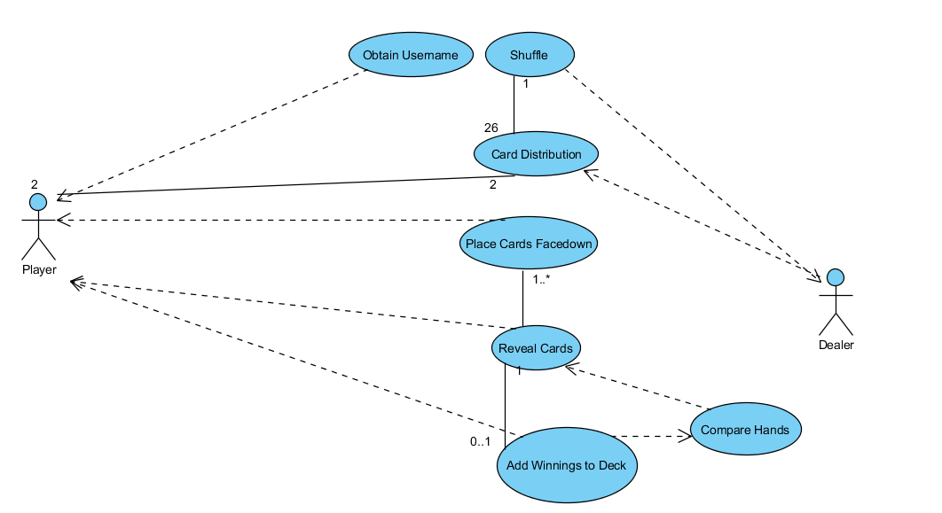

Figure 2.

Test Cases

